|  |  |  |  |  |  |  |  |  |  |  |  |  |  |  |  |  |  |
| --- | --- | --- | --- | --- | --- | --- | --- | --- | --- | --- | --- | --- | --- | --- | --- | --- | --- |
| 5 | 5 | 5 | 0 | 0 |  |  | 7 | 0 | 5 | 0 | 3 | 4 | 8 | 8 | 3 | 6 | 0 |

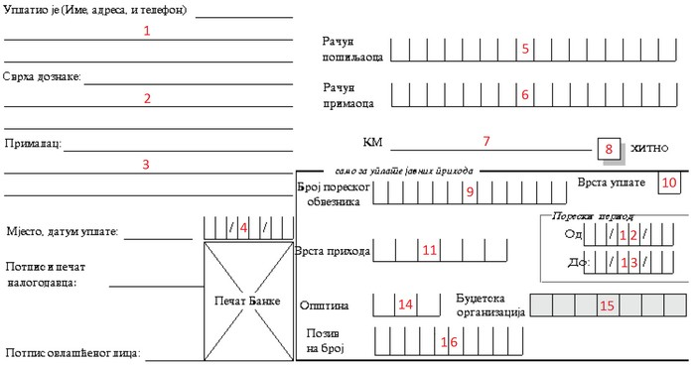

|  |  |  |  |  |  |  |  |  |  |  |  |  |  |  |  |
| --- | --- | --- | --- | --- | --- | --- | --- | --- | --- | --- | --- | --- | --- | --- | --- |
| 5 | 5 | 5 | 0 | 0 | 7 | 0 | 5 | 0 | 3 | 4 | 8 | 8 | 3 | 6 | 0 |

_Уплата административне таксе за____ регистрацију предузетника___________

|  |  |  |  |  |  |  |
| --- | --- | --- | --- | --- | --- | --- |
| 9 | 9 | 9 | 9 | 9 | 9 | 9 |

|  |  |  |
| --- | --- | --- |
| 0 | 0 | 8 |

|  |  |  |  |  |  |
| --- | --- | --- | --- | --- | --- |
| 7 | 2 | 2 | 1 | 3 | 1 |



|  |  |  |  |  |  |  |  |  |  |  |  |  |  |  |  |
| --- | --- | --- | --- | --- | --- | --- | --- | --- | --- | --- | --- | --- | --- | --- | --- |
|  |  |  |  |  |  |  |  |  |  |  |  |  |  |  |  |

Град Градишка

=30,00

Име и презиме, адреса, град__________